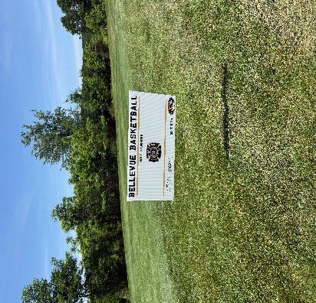
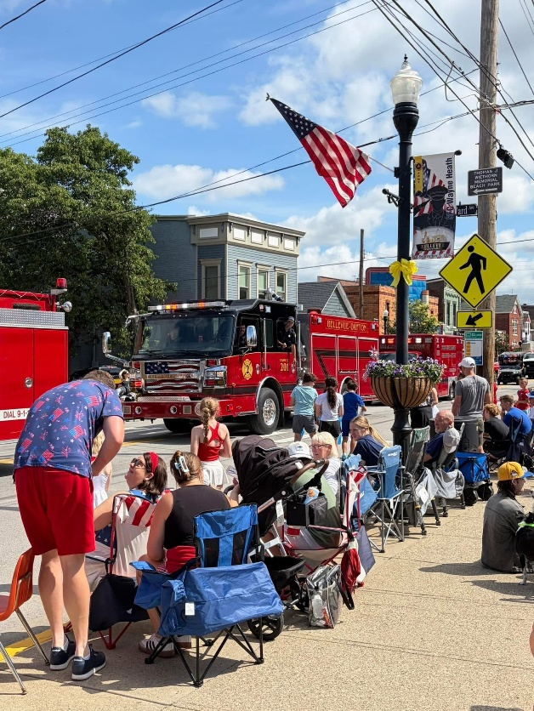

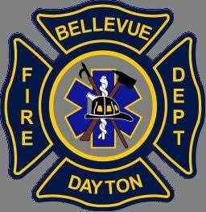
Fire Pit Safety

With fire pit weather upon us remember a few rules to be safe-
- Fires must be attended at all times
- Fires must be 15ft away from all structures
- Never burn trash, Plastic, treated wood, tires, or food waste
Memorial Day

It was amazing seeing the overwhelming turnout for the Memorial Day Parade. This day is not just about parades, fireworks, or pools. This day is to remember our Service members, Firefighters, Police Officers, and EMS who gave the ultimate sacrifice.
IAFF Local 3751

Local 3751 recently sponsored a hole in the Bellevue basketball golf outing. Along with sponsoring 1 member from Local 3751 and 2 retired members form Fort Thomas Local 1928 participated as well.
Contact info
Phone: (859) 261-0083 Office hours: 8am-4pm M-F Website: www.fdbd.org
Training

FDBD along with Newport FD and Covington FD participated in a Rail Car Incident Response training with an emphasis on Crude, Ethanol, and Other Flammable Liquids. This class consisted of classroom and hands on with a rail car prop.

Yearly Runs
Fire - 241
EMS - 581
Total - 822

May Runs
Fire - 49
EMS - 144
Total - 193

