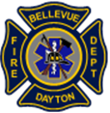
Fire Department of Bellevue-Dayton
Fire Pit Guidelines

Whether you're roasting marshmallows or enjoying a cozy evening outdoors,

It’s important to follow local fire pit rules to keep your neighborhood safe and

compliant.

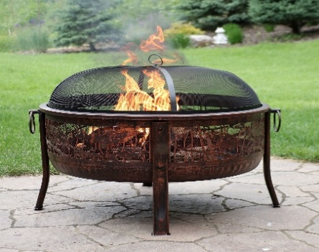

Fire Pit Rules per Kentucky fire code:
- Must use a commercially manufactured fire pit with a screen cover or
equivalent to contain sparks.
- Fire pit must be attended until fire is completely extinguished
- Keep a fire extinguisher or hose nearby.
- Fire pits must be at least 15 feet from structures or combustible materials.
- Never burn on windy days.
- Any fire that is deemed a nuisance can be ordered extinguished

General Guidelines (Statewide – Kentucky)
According to the Kentucky Energy and Environment Cabinet:
- ✅ Allowed: Small wood fires for warmth, cooking, and camping.
- ❌ Prohibited: Burning trash, plastics, treated wood, tires, or food waste.
- ⛔ Ozone Season Restrictions: From May 1 to Sept 30, open burning is not
allowed in Campbell County (includes Bellevue & Dayton)
- 🌲 Fire Hazard Seasons: From Feb 15–Apr 30 and Oct 1–Dec 15, burning
within 150 feet of woodland is only allowed between 6PM and 6AM.

