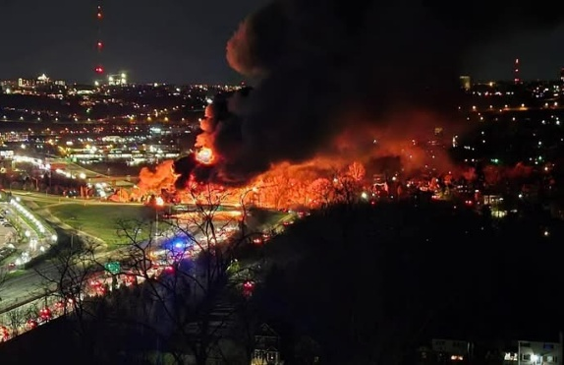
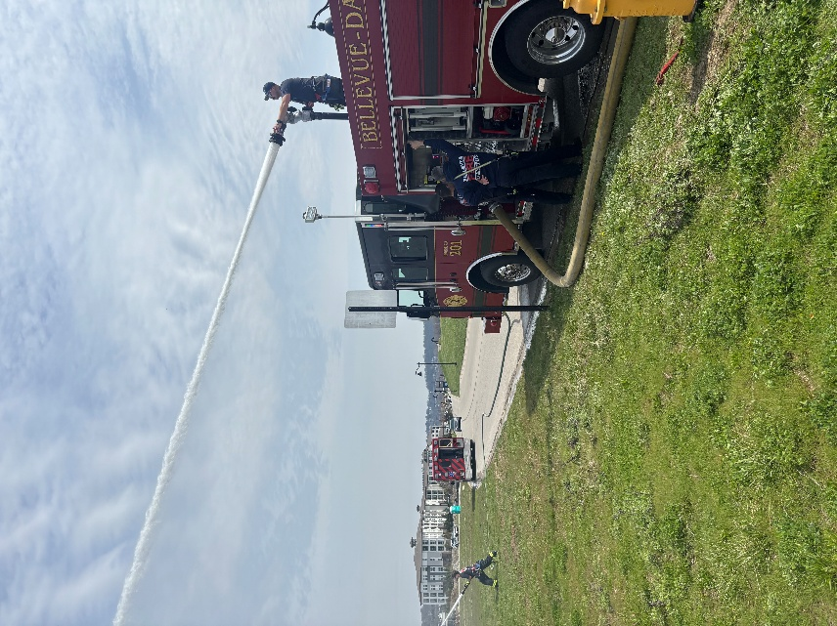

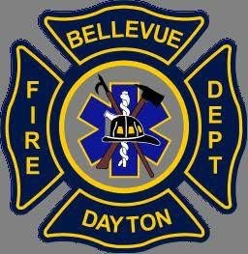
Where’s the Ladder?

Recently we have been getting questions on where our ladder truck is. Not to worry, the truck is safe and sound, it is just getting some maintenance work done. We hope to have it back soon!
Tanker Fire

FDBD would like to say job well done to everyone that responded to the tanker fire on 471. This event shows just how important mutual aid is to our region. 10+ fire departments responded including 2 from out of county and 2 from out of state for a total of 25+ apparatus on scene!
IAFF Local 3751

March Mania is in the air! March Madness has definitely not gone as most have thought, but we hope everyone is having luck on their Mania tickets!

Contact info
Phone: (859) 261-0083 Office hours: 8am-4pm M-F Website: www.fdbd.org
Training

FDBD took advantage of the warm weather that came through in March by doing pump ops training. This training was conducted to help prepare 3 members for their apparatus operator test out.

Yearly Runs
Fire - 141
EMS - 310
Total - 451

March Runs
Fire - 45
EMS - 98
Total - 143

