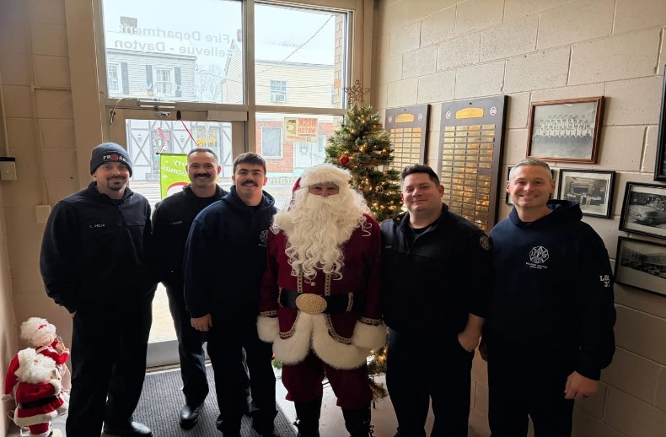
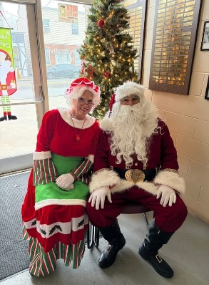
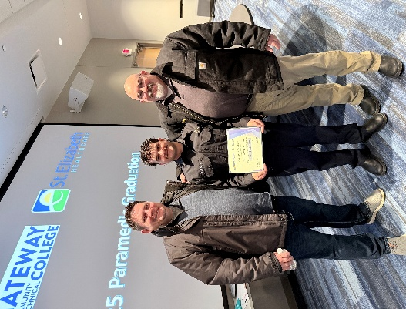
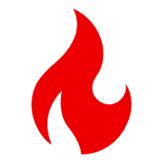
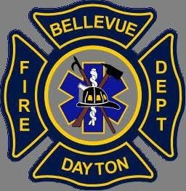
IAFF Local 3751
FDBD Local 3751 would like to say thank you to everyone that helped our Christmas fundraiser. We were able to bring toys, coats, and shoes to 12 families for a total of 39 kids! We would like to say Special thanks to Bellevue Kroger for donating enough food to help 16 families between both Bellevue and Dayton!

Yearly Runs
Total-2185
Fire - 683
EMS – 1502

Training
FDBD crews have been hard at work making themselves better. Collectively they completed 2667hrs of training. That’s over 111 Days! We would like to congratulated LT Knight on having the most training hours with 270!

FDBD Yearly Accomplishments
LT Ottaway became a Training Instructor
FF Pelle became a Training Instructor
FF Rath Completed Medic School
FF Nance was accepted into Medic School
Busy Busy Busy
2025 was a busy Year for our FDBD crews. They totaled 2185 Runs with almost ¾ of those being EMS runs. March was the Busiest month for EMS with a total of 138 runs. The busiest month for out fire crews was June with 82 calls for service.
December Runs
Fire - 54
EMS -125

Contact info
Phone: (859) 261-0083 Office hours: 9am-4pm M-F Website: www.fdbd.org

